Question 1

Try Test-Connection and nslookup commands for below websites

* www.google.com
* www.facebook.com
* www.amazon.com
* www.github.com
* [www.cisco.com](http://www.cisco.com)

Approach

nslookup stands for name server look up. It help to convert the domain name into ip address. It is used to query Domain name system to resolve the domain name into ip address

Test-Connection is used to check whether remote device is reachable or not

Below is the Test-Connection made to check the connectivity for given website. The alias command for test connectivity is ping. You can use ping command also. The major advantage o test connectivity is that it is highly customizable compared to ping. We can customize the delay, buffer size, count. But in ping we have limited packet control

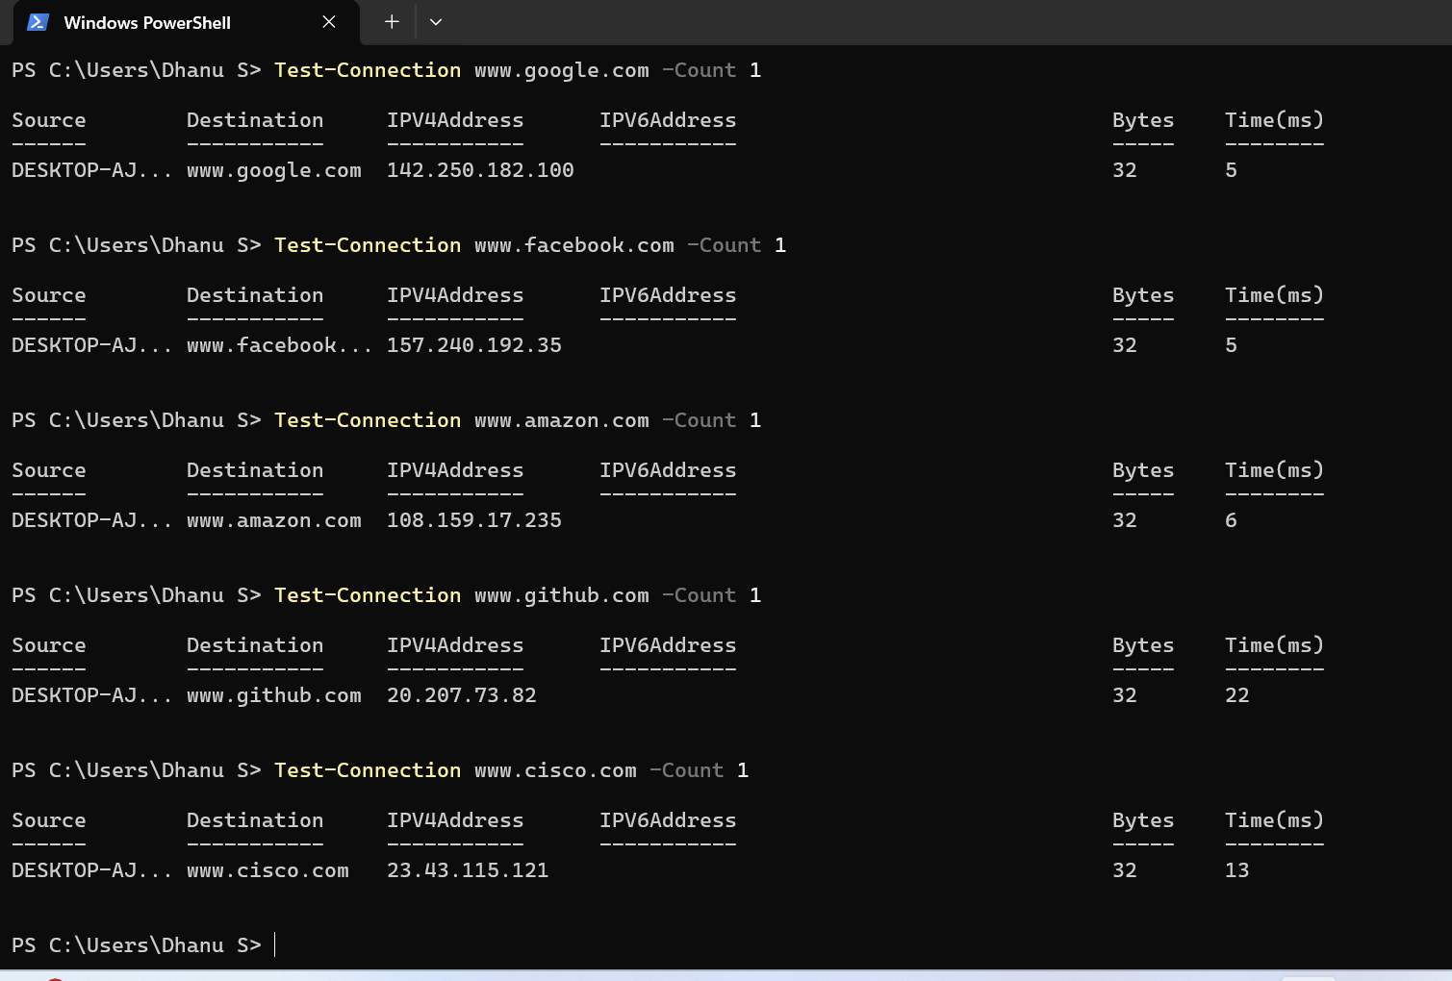

nslookup for the given website. We can see too many ip for some domain name, Because the website uses multiple servers worldwide to handle traffic effectively. Aliases refers to CNAME (Canonical name). This means the domain name does not directly map to ip. Instead, it is mapped to another domain name then to the ip address

